AWS KMS, Lambda and API Gateway

AWS KMS

1. What is AWS KMS?
A fully managed service to create, manage, rotate, and audit the cryptographic keys used to encrypt and decrypt data. AWS stores and manages the keys securely so you don't have to.

2. Why Do We Need AWS KMS?
Organizations store sensitive data — customer info, financial/medical records, secrets, backups, source code, configs. Without encryption, anyone who reaches the storage can read it. KMS encrypts this data and controls who can decrypt it.

3. Real-Time Example
A bank stores customer documents in Amazon S3 and needs: encryption at rest, access restricted to authorized employees, centrally managed keys, and a full audit trail of every encrypt/decrypt operation. AWS KMS covers all four requirements.

4. AWS KMS Architecture
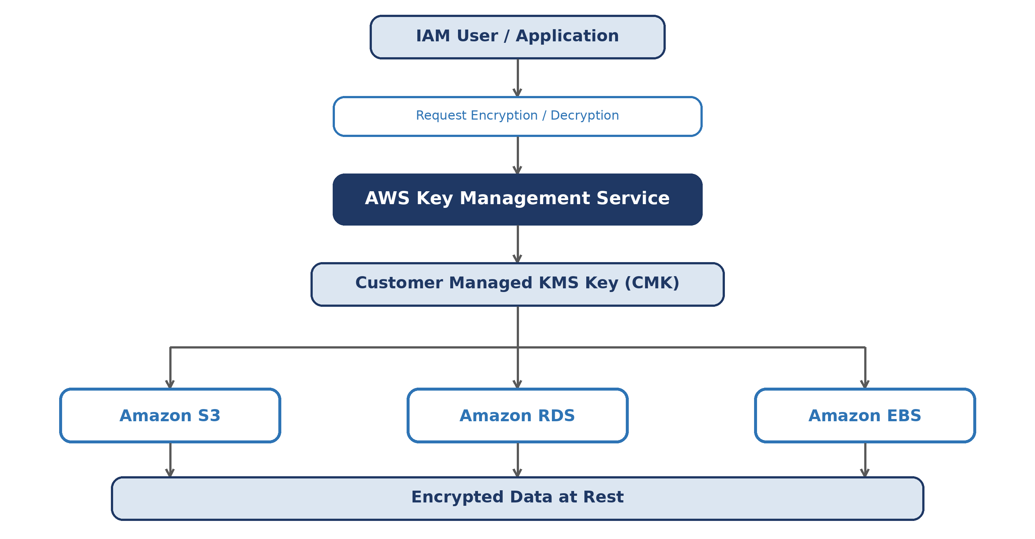

5. How AWS KMS Works
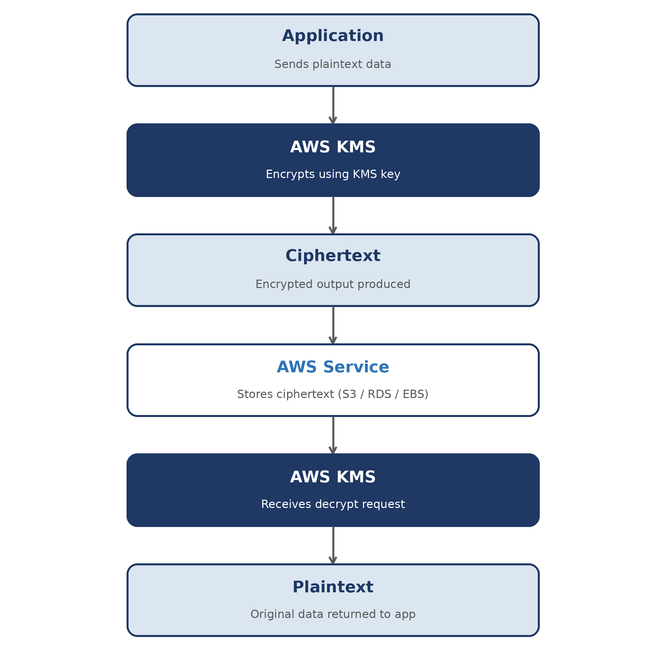

6. Key Components
Component | Description
KMS Key | Cryptographic key used for encryption and decryption
Customer Managed Key | Key created and managed by you
AWS Managed Key | Key automatically created by AWS
Alias | Friendly name for a KMS key
Key Policy | Controls who can use the key
IAM Policy | Grants users/roles permission to use KMS
Grants | Temporary permissions for services or apps
CloudTrail | Records KMS API activity

7. Types of Keys

AWS Managed Keys
- Created automatically by AWS; used by AWS services; limited customization
aws/s3 · aws/rds · aws/ebs

Customer Managed Keys (CMKs)
- Created by you — full control over policies, rotation, deletion, aliases
- Recommended for production workloads

AWS Owned Keys
- Managed entirely by AWS; not visible in your account; used internally by AWS services

8. AWS Services That Integrate with KMS
AWS Service | Use Case
Amazon S3 | Encrypt objects
Amazon EBS | Encrypt storage volumes
Amazon RDS | Encrypt databases
AWS Lambda | Encrypt environment variables
Amazon DynamoDB | Encrypt table data

Hands -on
1. Create Your First KMS Key — Step by Step
- Sign in to AWS Management Console
- Search for KMS (Key Management Service) → open it
- In the left menu, click Customer managed keys
- Click Create key
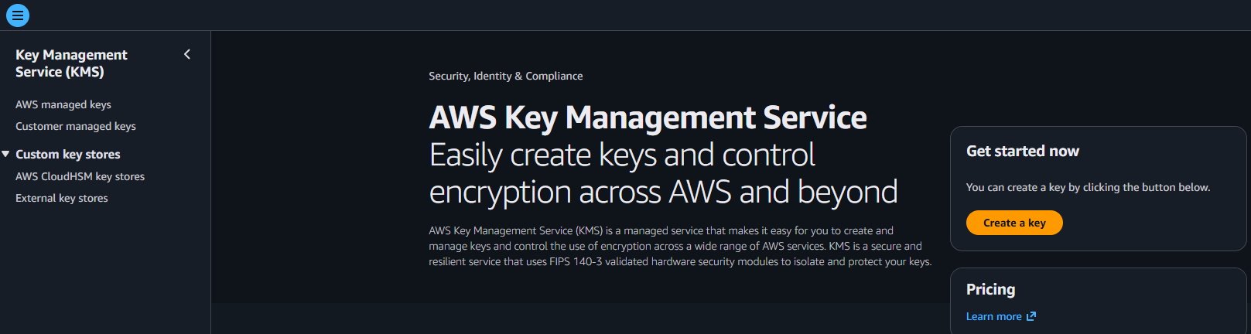
- Key type: select Symmetric
- Key usage: select Encrypt and decrypt
- Click Next
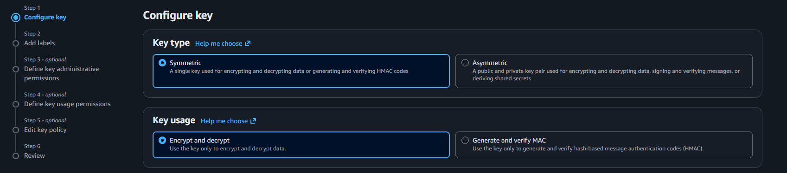
- Enter alias: my-first-key
- (Optional) Add description → Next
- Add yourself as Key Administrator → Next
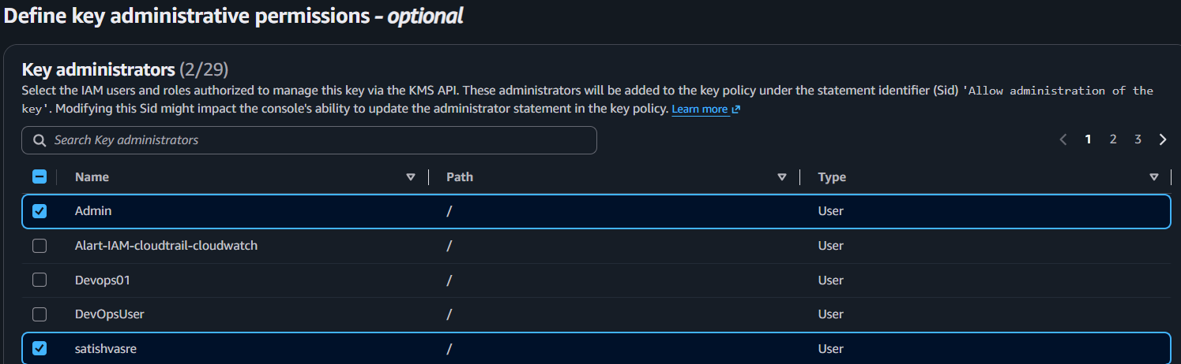
- Add yourself (or your role) as Key User → Next
- Review the key policy → click Finish
- Confirm the key appears in the list with status Enabled
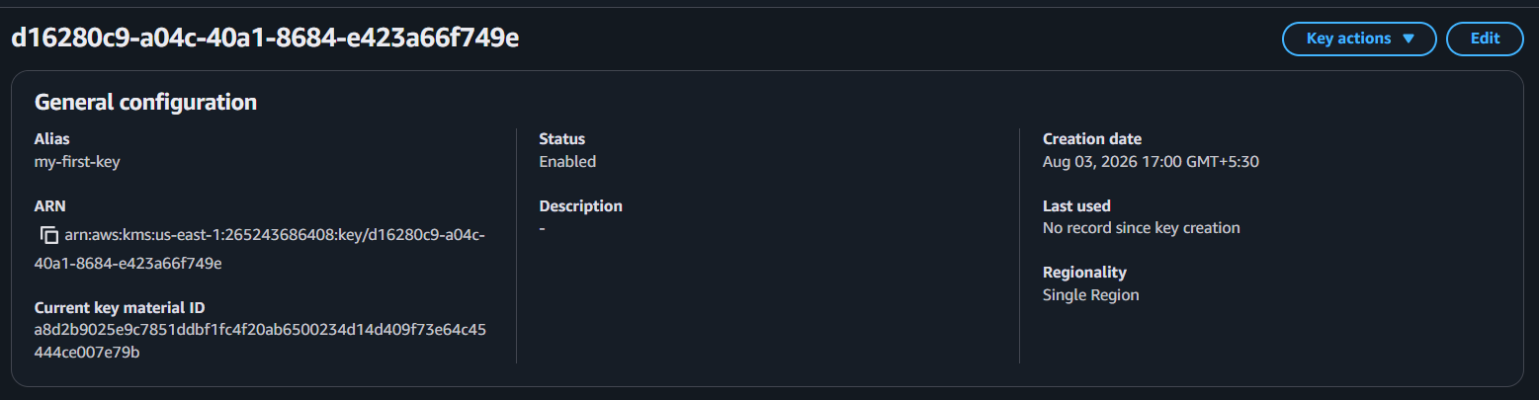

Hands-on 2: Encrypt a File Using AWS CLI
Prerequisites
- AWS CLI installed and configured (aws configure)
- my-first-key created in AWS KMS

Steps
- Open Terminal or Command Prompt.
- Create a sample file: echo "secret data" > secret.txt

- Get your KMS Key ID:
AWS Console → KMS → Customer managed keys
Copy the Key ID of my-first-key.
- Encrypt the file:
- aws kms encrypt \
- --key-id <KEY-ID> \
- --plaintext fileb://secret.txt \
- --output text \
--query CiphertextBlob > encrypted.txt
Replace <KEY-ID> with your actual KMS Key ID.
- Verify the encrypted file:
cat encrypted.txt
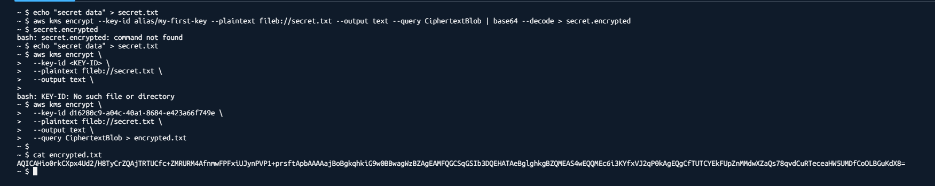

Expected Result
- secret.txt contains the original text.
- encrypted.txt contains encrypted ciphertext (Base64-encoded).
Note: If you're only doing AWS Console-based labs, you can skip this CLI task and continue with Task 3: Encrypt an S3 Bucket Using KMS.

3. Decrypt it back
Step 1: Convert Base64 to Binary
base64 -d encrypted.txt > secret.encrypted

Step 2: Decrypt the File
aws kms decrypt \
--ciphertext-blob fileb://secret.encrypted \
--output text \
--query Plaintext | base64 -d > secret_decrypted.txt

Step 3: Verify
cat secret_decrypted.txt
diff secret.txt secret_decrypted.txt
If there is no output, both files are identical.
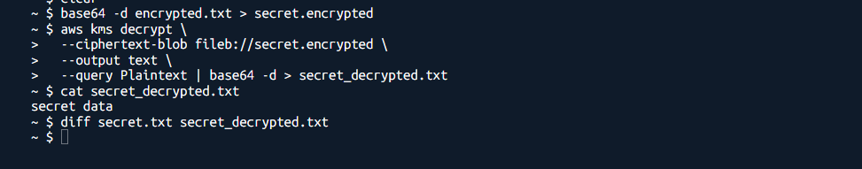
✅ This completes:
- Create KMS Key ✔️
- Encrypt File ✔️
- Decrypt File ✔️

- Turn on default encryption for an S3 bucket.

Step 1: Create an S3 Bucket
- Open S3
- Click Create bucket
- Enter bucket name (e.g., kms-demo-bucket-001)
- Click Create bucket
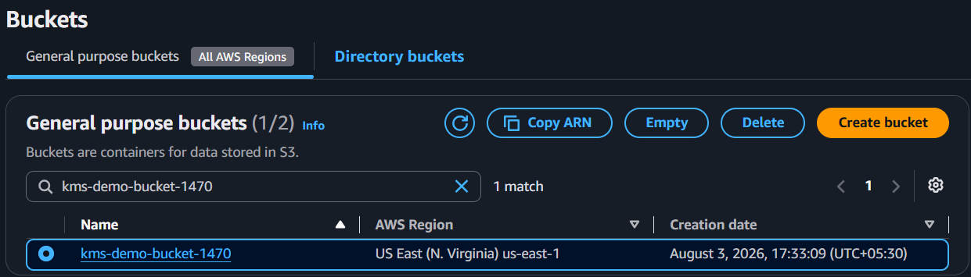
Step 2: Enable KMS Encryption
- Open the bucket
- Go to Properties
- Scroll to Default encryption
- Click Edit
- Select Server-side encryption with AWS KMS keys (SSE-KMS)
- Choose my-first-key
- Click Save changes
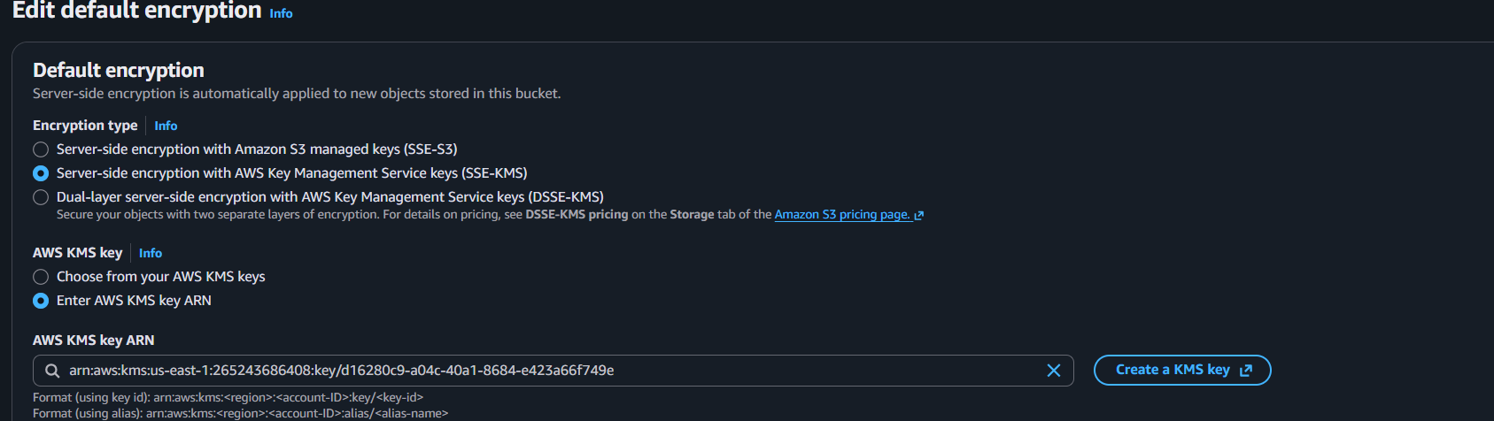
Step 3: Upload a File
- Open the bucket
- Click Upload
- Select any file (e.g., secret.txt)
- Click Upload
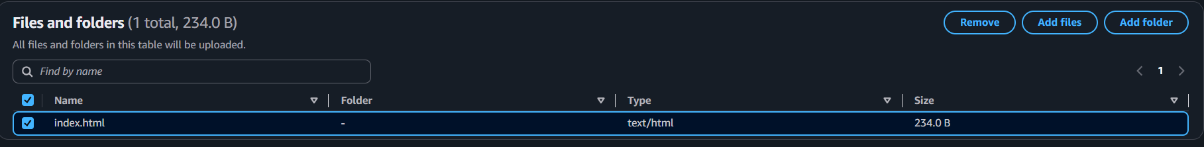
Step 4: Verify Encryption
- Click the uploaded file
- Go to Properties
- Scroll to Server-side encryption
- Verify it shows:
  - Encryption type: AWS KMS (SSE-KMS)
  - KMS key: my-first-key
Expected Result
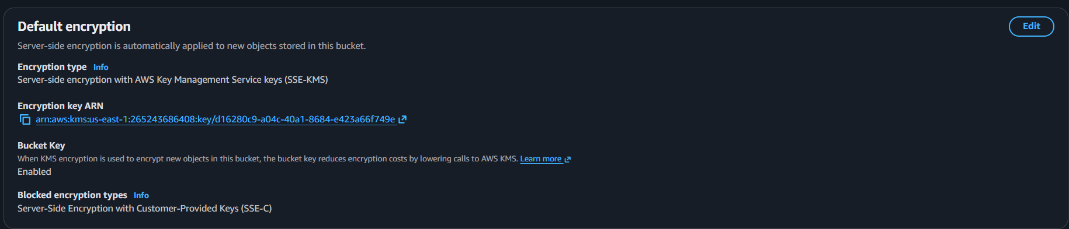
✅ The uploaded file is encrypted using your my-first-key KMS key.

- Create an encrypted EBS volume

Step 1: Open EBS Volumes
- Go to EC2
- Click Volumes
- Click Create volume
Step 2: Configure the Volume
- Select gp3
- Size: 8 GiB (or as needed)
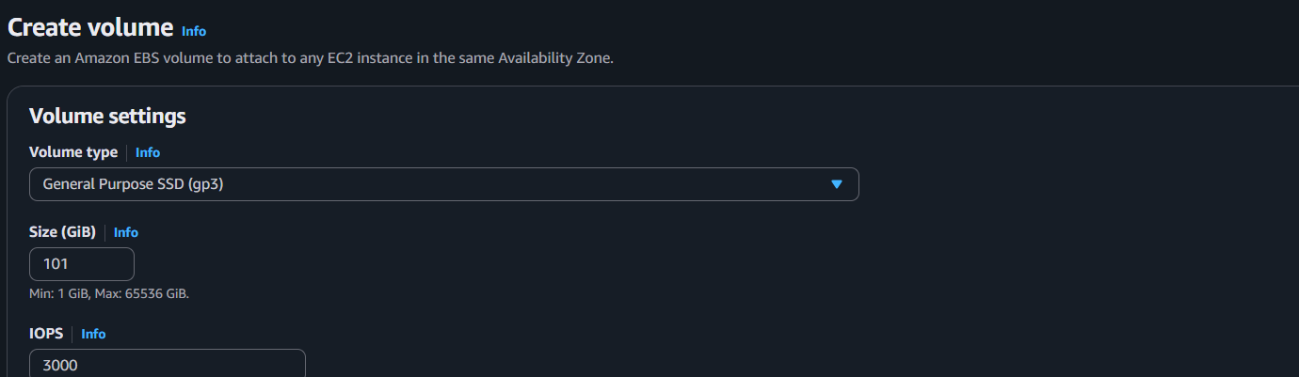
- Select the Availability Zone of your EC2 instance
- Enable Encryption
- Choose KMS key: my-first-key
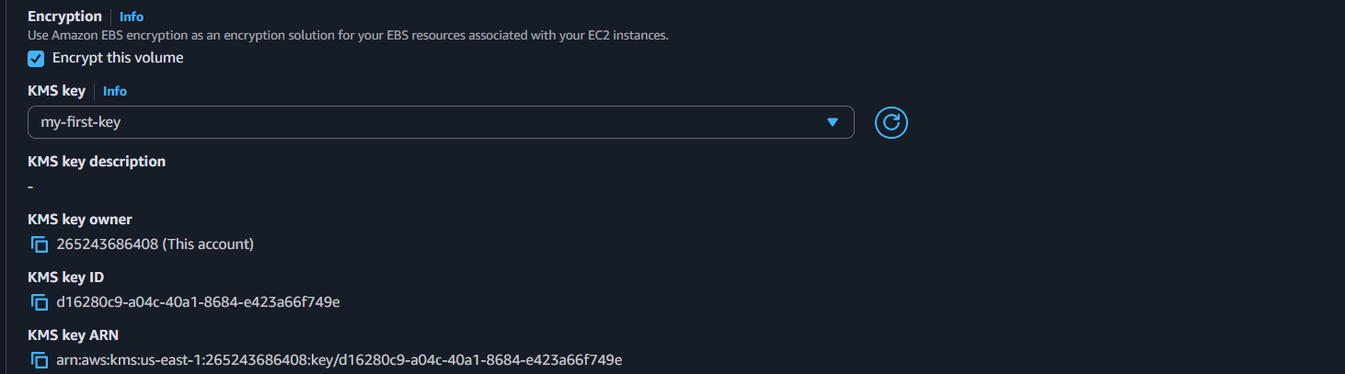
Step 3: Create the Volume
- Click Create volume
Step 4: Attach the Volume
- Select the new volume
- Click Actions → Attach volume
- Select your EC2 instance
- Click Attach volume
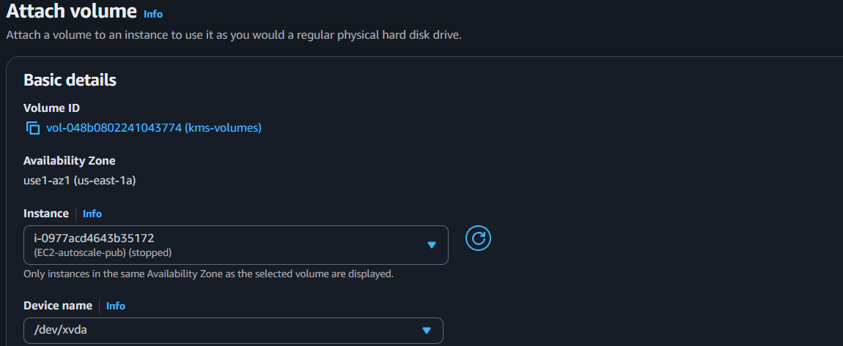
Step 5: Verify
- Check the volume status is In use
- Verify Encryption = Yes and KMS key = my-first-key
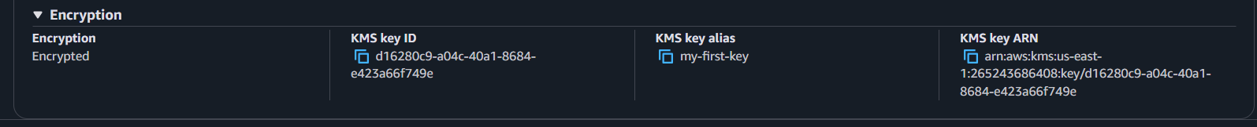
Expected Result
✅ An encrypted EBS volume is successfully attached to your EC2 instance using the my-first-key KMS key.

- Enable encryption on a new RDS database
RDS → Create database → scroll to Encryption → Enable encryption → choose my-first-key.
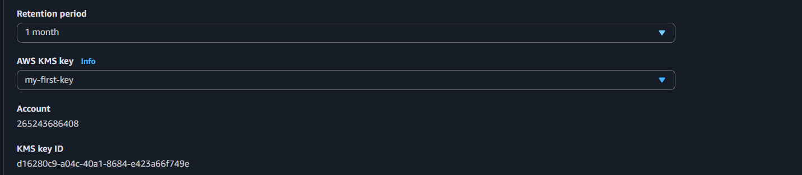
- View your key's permissions
Go to KMS
- Select my-first-key
- Open the Key policy tab
- Review:
- Key Administrators
- Key Users
- Root Account Permissions
- Expected Result: ✅ You can view the key policy and understand who can manage and use the KMS key.
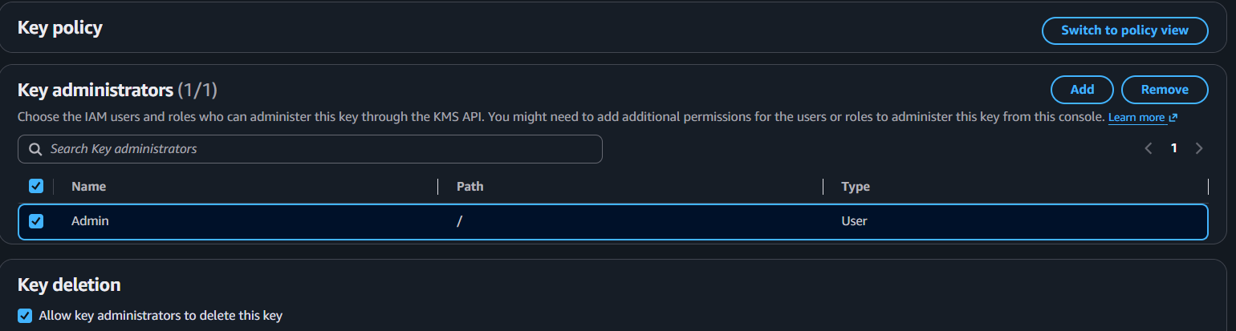

- Disable and re-enable a key
Go to KMS → Customer managed keys
- Select my-first-key
- Click Key actions → Disable
- Confirm Disable
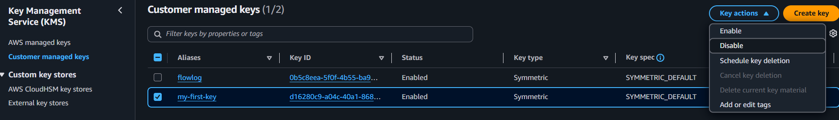
- Try encrypting a file (encryption should fail)
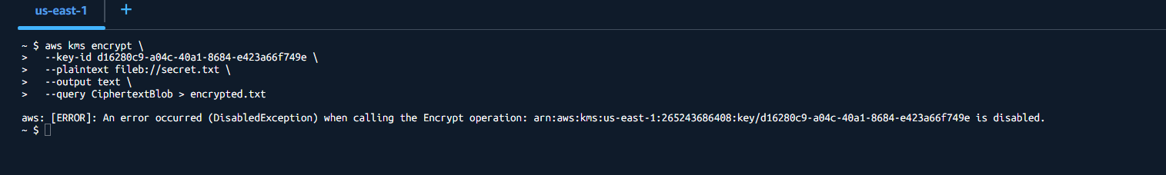
- Go back to Key actions → Enable
- Try encrypting the file again (encryption should succeed)
- Expected Result: ✅ Encryption fails when the key is Disabled and works again after the key is Enabled.
- Check key usage in CloudTrail
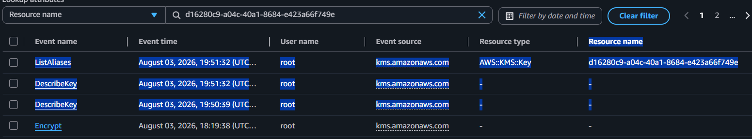
CloudTrail → Event history → filter by "Resource name" = your key ID. See the Encrypt/Decrypt events show up.

AWS LAMBDA

1. What is AWS Lambda?
AWS Lambda is a serverless compute service that lets you run code without creating or managing servers. You upload your code, and AWS runs it automatically when an event occurs.

2. Components of Lambda
Component | Purpose
Function | Your application code
Trigger | Starts the Lambda function
Runtime | Programming language (Python, Java, Node.js, etc.)
Handler | Entry point of your code
IAM Role | Permissions to access AWS services
Environment Variables | Store configuration values
Layers | Reusable libraries and dependencies
CloudWatch | Logs and monitoring

3. Why Use Lambda?
Use Lambda when:
- ✅ Build REST APIs with API Gateway
- ✅ Process files uploaded to S3
- ✅ Send notifications (SNS)
- ✅ Process SQS queue messages
- ✅ Run scheduled jobs (EventBridge/Cron)
- ✅ Process DynamoDB Streams
- ✅ Automate AWS tasks (backups, tagging, cleanup)

4. Why NOT Use Lambda?
Lambda is not a good choice when:
- ❌ Applications run continuously (24×7)
- ❌ Long-running jobs (more than 15 minutes)
- ❌ Large applications requiring full server control
- ❌ Software that needs a GUI
- ❌ Applications with persistent local storage requirements
Example:
Running a database like MySQL or hosting a full Tomcat server is not suitable for Lambda. Use EC2, ECS, EKS, or RDS instead.

AWS Lambda Hands-on

Lab 1: Create Your First Lambda Function
Step 1: Open Lambda
- Log in to the AWS Console.
- Search for Lambda.
- Open the Lambda service.
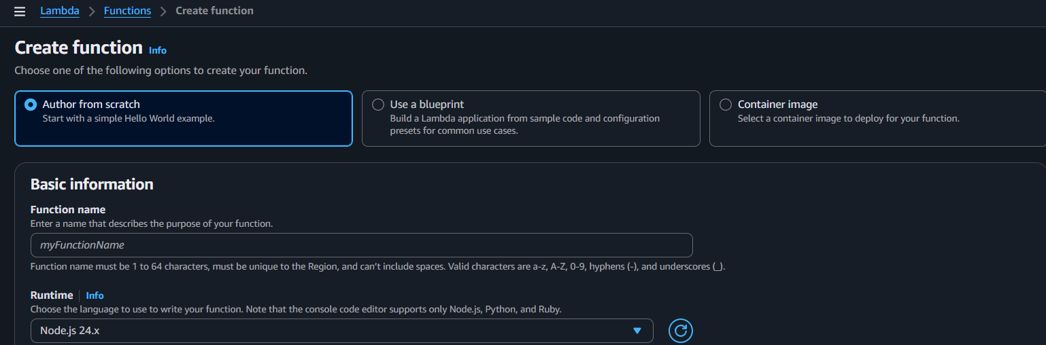

Step 2: Create Function
Click Create function.
Select:
- Author from scratch
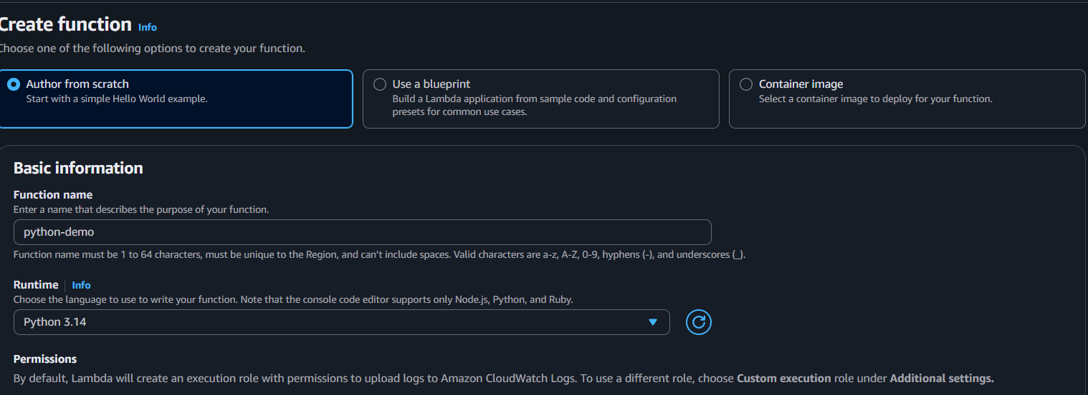

Step 3: Write Code
Go to the Code tab.

def lambda_handler(event, context):
return {
"statusCode": 200,
"body": "Hello AWS Lambda"
}

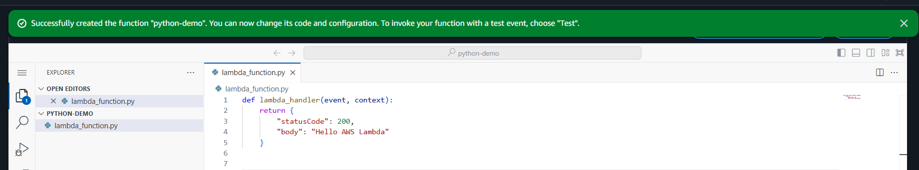

Step 4: Deploy
Click Deploy.
Purpose: Saves the latest code to AWS so it can be executed.
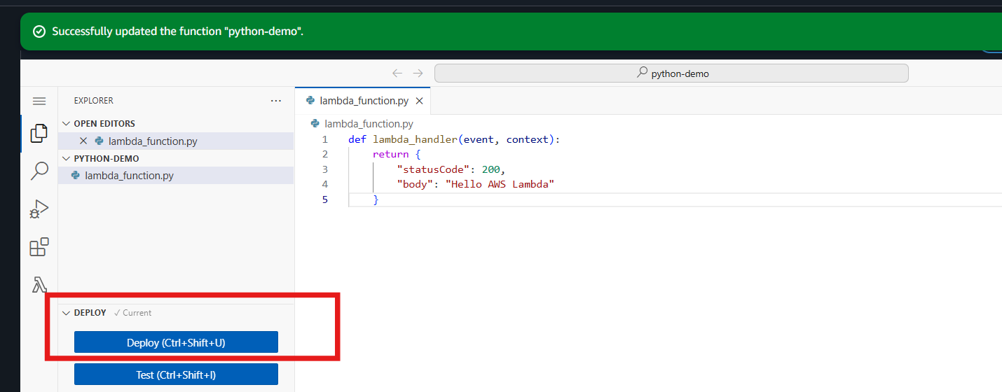

Step 5: Test
Click Test.
- Event name: TestEvent
- Keep the default JSON:
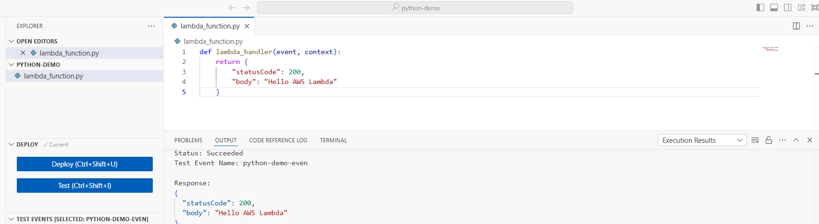

Step 6: View Logs
Go to: Monitor → View CloudWatch Logs
Open the latest log stream.

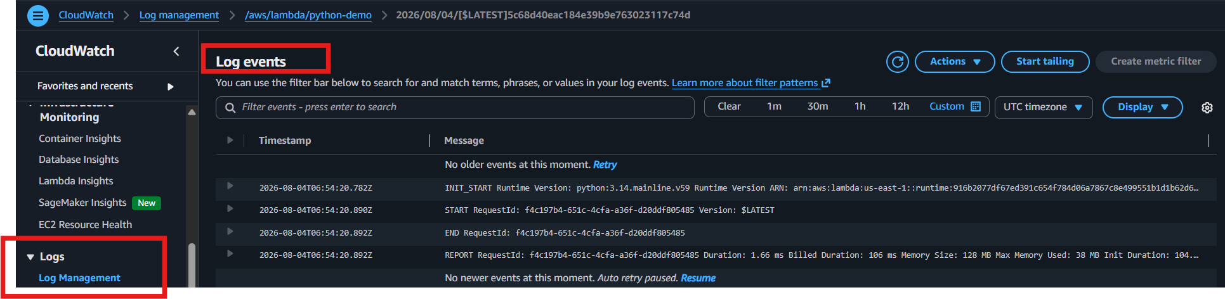

Update Lambda Code
- Edit the code.
- Click Deploy.
- Click Test.
- Verify the updated output.
Remember: Every code change requires Deploy before testing.

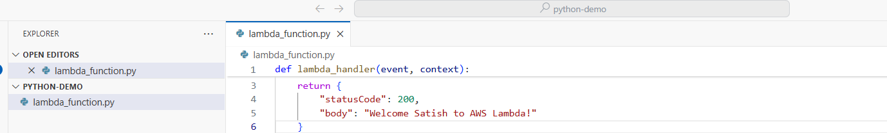

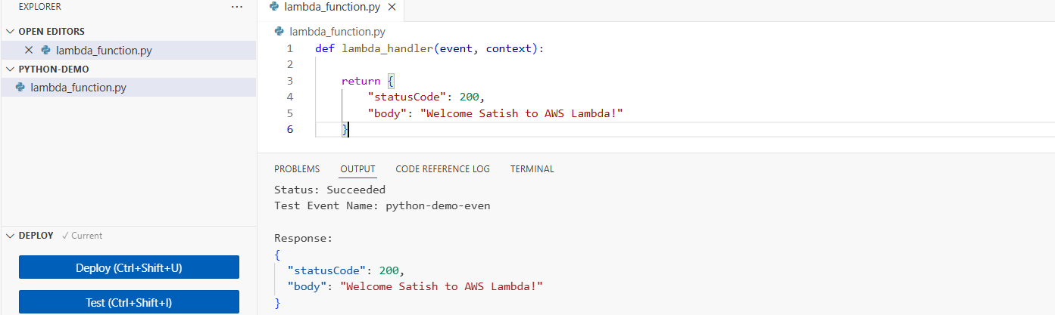

Add Environment Variables
Go to:
Configuration → Environment Variables → Edit
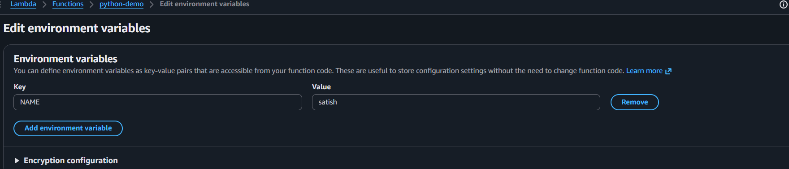

AWS API Gateway

Step 1: Open API Gateway
- AWS Console → Search API Gateway
- Click API Gateway

Step 2: Create API
- Click Create API
- Select HTTP API
- Click Build
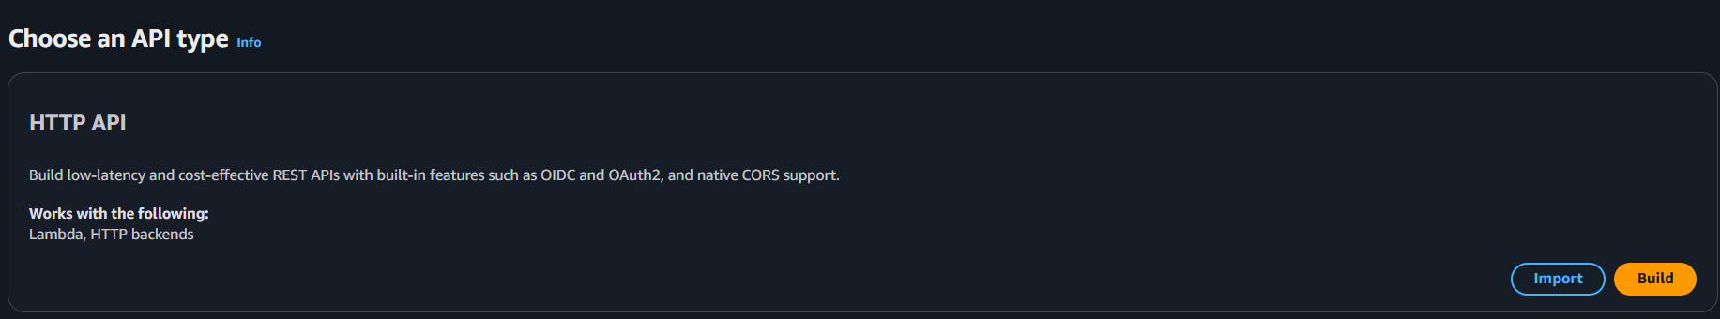

Step 3: Add Integration
- Click Add Integration
- Integration type: Lambda
- Select your Lambda function (e.g., python-demo)
- Click Next
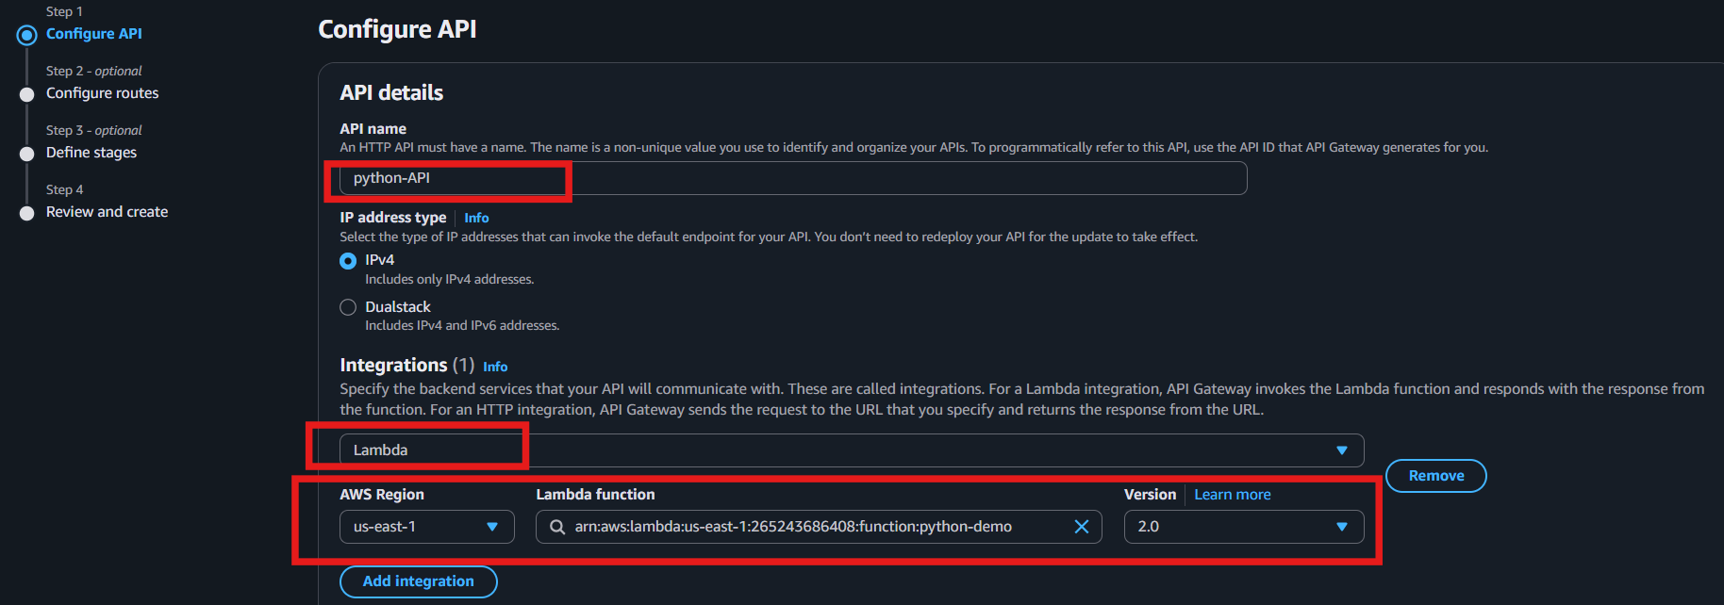

Step 4: Create Route
- Method: GET
- Path: /hello
- Click Next
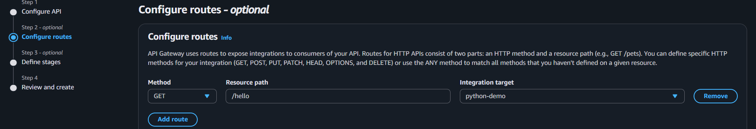

Step 5: Create Stage
- Stage name: prod
- Click Create
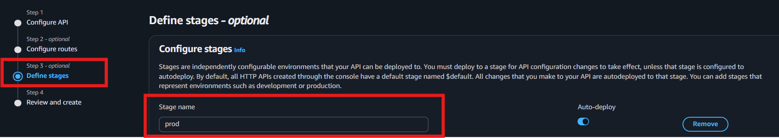
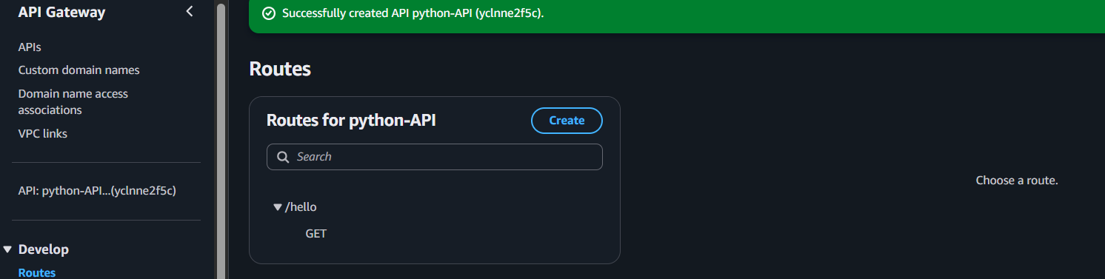

Step 6: Copy Invoke URL
Example:
https://yclnne2f5c.execute-api.us-east-1.amazonaws.com/prod
Append the route:
https://yclnne2f5c.execute-api.us-east-1.amazonaws.com/prod/hello

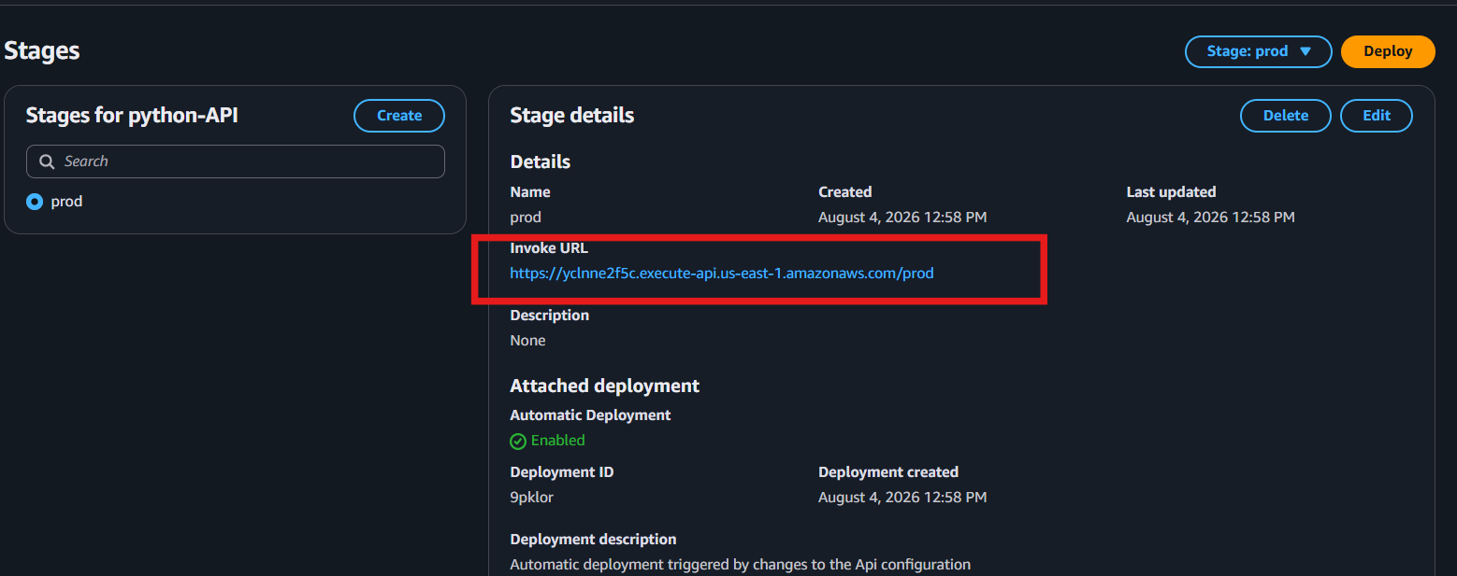
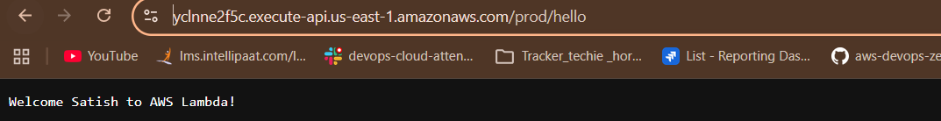

Step 7: Test API
- Open the URL in a browser or Postman.
- You should see:
{
"statusCode": 200,
"body": "Hello AWS Lambda"
}

Step 8: Verify Logs
Go to:
Lambda → Monitor → View CloudWatch Logs
Open the latest log stream and verify the API request reached Lambda.
